

**Digitally Driving Traffic Checklist**

This tool will help identify opportunities to to help drive traffic to your dealership by reaching customers online.

**Review Each Item:**

# **ImProve search and paid Digital marketing**

**What comes up when you do a Google/Bing/MSN/Yahoo search for your dealership?**

Search like a customer – For example, try searching “*dealership name*”, “*brand* auto service” and “dealership near me.” Do you see your dealership in the Search Results?

* 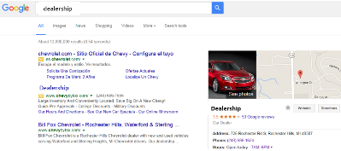Look for evidence of paid search or sponsored links (this helps you appear first)
* Do you see your dealership in natural/organic search?
* Make sure your address, phone # and hours are correct for both sales & service

**TAKE ACTION:** Note and update any outdated information you find. Sign up for a paid search program to help increase your search presence (more info below) and work with your CDK ProCare Advocate to add content to your website.

**Online Directory Listings - Are listings claimed and updated with service related content?**

Ensure accuracy. Sometimes this information is outdated or incorrect. Customers may not realize that the information was generated by the directory and any errors will reflect on your dealership. Don’t neglect to include relevant service-related keywords.

* + Google Places
  + Yext (Yahoo local)
  + MapQuest
  + SuperPages
  + Whitepages
  + local.com
  + Yelp
  + Citysearch
  + Yellowpages

**TAKE ACTION:** Review and update your dealership’s online directory profiles to ensure accuracy and include service related keywords.

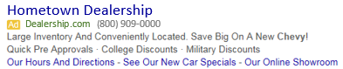

**Are you effectively using paid digital advertising for sales and service?**

Digital advertising is a great way to boost your sales and service traffic by promoting your online content to in-market customers through paid search and targeted display advertising. To maximize your effectiveness, run advertising continuously and review your metrics.

**TAKE ACTION:** For more information go to [**Global Connect**](https://dealer.autopartners.net/portal/us/Pages/default.aspx) and view the Dealer Vendor Advisor to learn about the Digital Advertising opportunities available to GM Dealers.  For more information about Digital Advertising available through the GM Digital Marketing Package contact CDK at **877-333-3138** or learn more at [**www.gmpackageguide.com**](http://www.gmpackageguide.com).  For more information on Epsilon’s Evolution program go to [**Global Connect**](https://dealer.autopartners.net/portal/us/Pages/default.aspx) or contact Epsilon at **800-292-9220** to enroll in their search marketing program.

**What are your star ratings? How many reviews are there?**

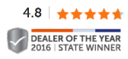User reviews are proven sales drivers and something a majority of customers want to see before deciding to make a purchase from your business.

* Google Score _____
* Yelp Score _____
* DealerRater.com Score _____
* Consumerperceptionrating.org _____

**TAKE ACTION:** Enroll with an approved Reputation Management vendor.

# **WEbsite Content**

**Inspect the Vehicle Details pages. Look at your:**

* Pricing Strategy?
* Vehicle Photos: Stock or Actual (recommended)?
* Vehicle Descriptions?

**TAKE ACTION:** Review your dealership’s website and update as needed.

**Are you displaying current sales promotions & incentives?**

Customers are searching both on their desktop and mobile devices.

* Are you using the integrated feed?
* Do you display brand promotions?
* Have you opted-in to lease advertising?
* Can consumers easily find offers on new/used?
* Are the sales specials displaying your best price?

**TAKE ACTION:** Ensure you are keeping offers up-to-date.

**Does your website have Service Specials on the Specials Page and a Service Menu?**

Including service specials and a service menu are good ways to increase search engine rankings. When developing the details, focus on describing them in ways customers would search rather than in technical terms. Be sure to include keywords and content about services (Tires, Oil Change, Brake Repair, etc.).

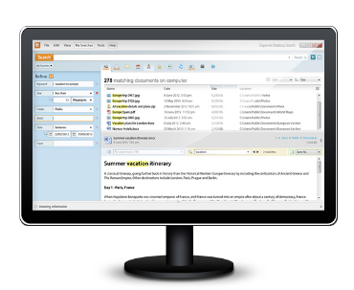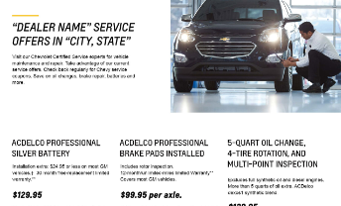

**TAKE ACTION:** Promote service specials. If enrolled, display all National Retail Plan offers. Either self-manage, work with your CDK ProCare Advocate or enroll in Connected Service Offers (CSO) by contacting Epsilon at **800-292-9220**. Also, speak with your CDK ProCare Advocate about adding a service menu.

**Inspect the content and assets on each page (both desktop and mobile):**

* Are images showing current vehicles and logos?
* Are you promoting tires and displaying tire pricing with Tire Finder?
* Are you participating in Shop-Click-Drive?
* Add video widgets to improve engagement.
* Evaluate website navigation and identify opportunities to improve.

# **lead management**

**Do you have a Dealer Management System (DMS) integrated version of Online Service Scheduling?**

Consumers want the convenience of scheduling their appointment online. Integrating your scheduling with your DMS makes it easy.

**TAKE ACTION:** For details, contact DBC at **888-337-1010** – prompt 1, then prompt 2.

**Does your dealership have a robust Sales and Service Lead Management process?**

[](http://www.google.com/url?sa=i&rct=j&q=&esrc=s&source=images&cd=&cad=rja&uact=8&ved=0ahUKEwic_unXn6DMAhWKuoMKHbTaB44QjRwIBw&url=http://www.kunocreative.com/blog/bid/64511/Webinar-Maximizing-Conversion-Rates-With-Marketing-Automation&psig=AFQjCNF9ydeWJ6Dk1o-FmnC9Ze-1UEyMuQ&ust=1461345807598325)Capture all customers that are in-market looking for a new/used vehicle or services. Establish & continuously improve both sales and service lead processes. Service leads are an absolutely critical element in retaining more customers. When reminded, almost all customers who schedule service online keep their appointment. The #1 customer dissatisfier is when the dealer does not respond.

**Sales**

* Request a Quote
* Phone Calls

**Service**

* OnStar Dealer Maintenance Notifications
* Website Leads
* Phone Calls

**TAKE ACTION:** To learn more about Service Leads, search “leads” on **GlobalConnect**.

# **Reporting and metrics**

**Dealer Command Center**

Log into DEALER COMMAND CENTER to view the following:

**Customer (Website Performance) Tab**

Unique Visitors vs. Phone Calls + Leads + Hours & Directions = CONVERSION

Industry average is about 20% - How are you preforming?

Use the Map to see where the prospects are/are not coming from

Is there a balance between HIGH/MID/LOW activity on the Visitor Engagement Funnel?

**Traffic Tab**

Evaluate areas in your websites getting the most and least traffic

What are your top website areas?

**Inventory Tab**

Evaluate inventory that is getting fewest VIN Views and Leads

Check the Shopper Segments and see how many visitors are looking for “Parts & Service”

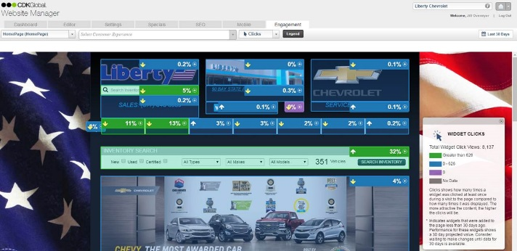**Advertising Tab**

Evaluate your campaign performance

Look at the brand funded advertising

**Website Manager section, under Engagement tab**

Use your Engagement map to see page performance

**Download The Service Digital Performance Report (DPR) and review the following:**

Lead Volumes

Response Performance

Lead to Repair Order Conversion Rates (i.e. Close Rate)

Revenue Generated (By Lead Type)

Revenue Lost (By Lead Type)

**TAKE ACTION:** Consistently monitor your Service Lead performance and embrace a culture of continuous improvement to improve results and customer experience.

# **Social Media**

**Is your dealership active in social?** 

Have you established a presence? Are you actively monitoring posts and adding your own content?

**TAKE ACTION:** Set up and develop a monitoring plan for your social pages.

**Chevy Dealers - Are you using PromoBoxx?**

Need more content for your Facebook or Twitter pages? We provide dealers with FREE, brand-aligned content 2-3 times a week, provided by Chevrolet PromoBoxx. Plus, signing up is easy.

**TAKE ACTION:** Enroll today at [**www.chevydealersocial.com**](http://www.chevydealersocial.com).

**Buick, GMC and Cadillac Dealers - Are you promoting Service through social channels?**

To make it easy, use the Quarterly Certified Service Social Marketing Package to assist with consumer focused service content. Each post is designed to drive traffic to your dealership and is written to build social familiarity and trust. The tips are brand specific and meant to drive engagement.

**TAKE ACTION:** Download the most recent Social Marketing Package from [**www.gmassetcentral2.com**](http://www.gmassetcentral2.com).

**Key Digital Resources**

**Sales & Service**

* GM Asset Central and Cadillac Brand Center
  + Online Advertising Creative
  + Photos/Images
* GM Digital Marketing Package - [**gmpackageguide.com**](http://gmpackageguide.com/) or **877-333-3138** for Cadillac - **cadillacdigitalmarketing.com**
* Chevrolet PromoBoxx - [**www.chevydealersocial.com**](http://www.chevydealersocial.com)
* Epsilon - Evolution Digital Advertising Package - **800-292-9220**

**Service Specific**

* CDK - Service and Parts Search - [**http://www.gmpackageguide.com/sites/gmpackage/files/GM_AdSupport_CSPS.pdf**](http://www.gmpackageguide.com/sites/gmpackage/files/GM_AdSupport_CSPS.pdf)
* Epsilon - Certified Service Local Internet Search Program - **800-292-9220**
* Epsilon - Website Specials - Connected Service Offers - **800-292-9220**
* GM Tire Program Team - **877-728-4737** or [**www.gmtirebilling.com**](http://www.gmtirebilling.com).
* Online Service Scheduling (GM version) - **888-337-1010** – prompt 1, then prompt 2
* Center of Learning -[**www.centerlearning.com**](http://www.centerlearning.com)